Risk management

The definition of a project highlights:
- once-off, change inducing nature of projects
- central role of objectives in project definition

Role of risk management
***
is usually associated with evaluation and the
development of contingency plans supporting the base plan
***
- improve project performance by way of management of project related risk.
- focuses on reducing threats.

Baseline plan – a target scenario of how one would like a project to go.

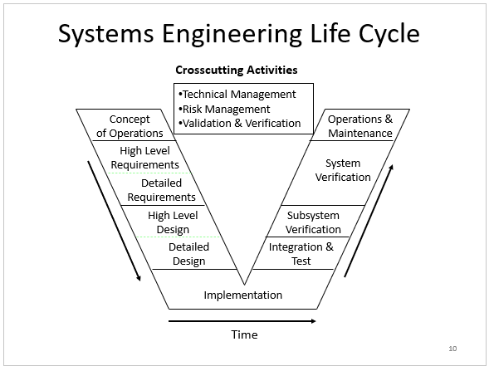

Project Risks
Threats to the project:- inadequate funding
Technology:- performance problems, interface problems
People:- low skill levels, fear of change
Management:- requirement changes, inadequate resources

Sources of these risks include:
- technology
- people
-physical and political environment
- contract issues

Boehm’s list (top software risk items)
- personnel shortfalls
- unrealistic schedules and budgets
- developing wrong software functions
- real-time performance shortfalls
- continuous requirement changes
- developing the wrong user interface

Top 10 golden rules
- Make risk management part of your project
- Identify risks early
- Communicate about risks
- Consider both threats and opportunities
- Clarify ownership issues
- Prioritise risks
- Analyse risks
- Plan and implement risk responses
- Register project risks
- Track risks and associated tasks

Risk retirement (mitigation) – the process whereby risks are reduced

Important risks have to be managed through well-defined plans

Important techniques:
- buying information
- risk avoidance
- risk transfer
- risk reduction

Risk management techniques
The following risks can be dealt with using various techniques:
Personnel shortfalls
- top talents, team building, job matching

Unrealistic schedule and budget
- detailed estimation, incremental development, reuse

Developing wrong functionality
- prototyping, analysis, user participation

Requirement changes
- information hiding, incremental development

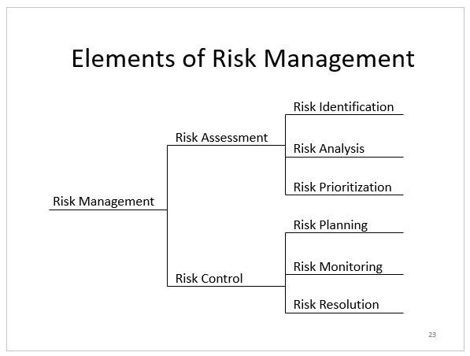

Risk assessment considerations
Likelihood of occurrence
- this can be expressed as a probability (0-1 or a percentage)

Potential impact
- calculating how much money it will cost if the risk occurs

Mitigation cost
- checking the cost of mitigating the risk

Risks can be assessed quantitatively
- probability
- cost/severity of impact
- mitigation cost

Expected risk cost = probability x cost of impact

SCENARIO:
Let us say you had a risk that would cost the project an additional R100, 000.
At first glance, that would seem like a major risk. However, supposed you assessed the likelihood of that risk occurring as being one in 100. Using the formula:

Expected Risk Cost = $100,000 x (1/100)
Or
Expected Risk Cost = $100,000/100 = $1,000

So the calculation of “expected risk costs” yields a value of $1,000.
That means you shouldn’t invest more than $1,000 to mitigate the risk.

Top 10 risks
- personnel shortfalls
- unrealistic schedules and budgets
- functions not right
- user interface not right
- requirements change
- external dependencies

Here are some risk scenarios:

RISK #1
Contractors worry that agencies will not review
design documentation (requirements, specifications, etc.)
When the final system does not meet their expectations
they are asked to revise the final product – at great cost!

- How would you avoid the risk?
- What is your mitigation strategy?

ANSWERS
1. Include submissions and review times in schedule
2. At monthly review meetings discuss schedule and impacts of review slippages
3. Agree that the contractor will never proceed with work that depends on completed review

Resolution
- plan should include identification of compensation to contractor for schedule slippage caused by agency

RISK #2
Agencies worry that contractors will not assign
adequate personnel to keep the project on schedule.

- How would you avoid the risk?
- What is your mitigation strategy?

ANSWERS
1. Review schedule at monthly meetings
2. Include metrics at review meetings
3. Insist that contractor identify actions to be taken when slippage occurs.

Resolution
- identify functions to be eliminated in the event of schedule slippage
- agree to extend the schedule

Quality

Quality Management activities
Quality planning: select applicable procedures and standards for a particular project and modify these as required.

Quality assurance: establish organizational procedures and standards for quality.

Quality control: ensure that procedures and standards are followed by the software development team.

Design review
- formal documentation of a design to evaluate the design requirements and the capability of the design to meet these requirements and to identify and propose solutions.

Quality attributes for a product
For a software, it is necessary to have the following attributes beyond meeting functionality requirements:
- efficiency: software should not be wasteful with system resources (memory, CPU time, disk space)
- usability: software should be usable by the users for which it was designed.
- dependability: reliability, security, safety, availability
- maintainability: software must evolve to meet changing needs.

Other quality attributes include:
- resilience
- adaptability
- reusability
- robustness

Software metric
- any type of measurement which relates to a software system or related documentation (lines of code in a program, Fog index etc)

Dependability and critical systems
Types of critical systems:
Safety-critical system – is a system whose failure may result in injury, loss of life, or major environment damage.
Mission-critical system – a system whose failure may result in the failure of some goal-directed activity.
Business-critical system – is a system whose failure may result in the failure of the business using the system.

Product quality metrics
- usually measured by the number of “bugs” in the software or how long the software can run before encountering a “crash”.
Two good examples are:
Mean time to failure: which refers to the time between failures.
Defect density: defects relative to the software size (lines of code, function points etc).

ISO approach
consists of 3 factors:
-Quality Planning
-Quality assurance
-Quality control

Importance of standards:
• helps avoid past mistakes
• provides continuity
• ensures following compliance to standards

Problems with standards
• may not be seen as relevant and up to date
• requires more manual work if unsupported by software tools

Non propriety approaches include:
•Total Quality Management
•Continuous improvement

===
The quality of a developed product is influenced by the quality of the production process
.===

Process and product quality
-The quality of a developed product is influenced by the quality of the production process.
-This is important in software development as some product quality attributes are hard to assess.

Process based quality
-There is a straightforward link between process and product in manufactured goods.

More complex for software because:
• The application of individual skills/experience is important in software development
• External factors such as the novelty of an application or the need for an accelerated development schedule may impair product quality.

-it is important, to not impose inappropriate process standards - these could reduce rather than improve the product quality.

Practical process quality
-defines process standards such as how reviews should be conducted, configuration
management, etc.

ISO 9000
- international set of standards for quality management.
- applicable to a range of organisations from manufacturing to service industries.

ISO 9001
- a generic model of the quality process that must be instantiated for each organisation using the standard.
- applicable to organisations which design, develop and maintain products.
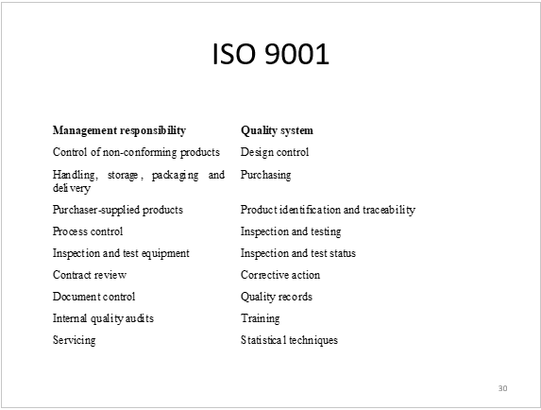

DOCUMENT STANDARDS
Documentation process standards: concerned with how documents should be developed, validated and maintained.
Documentation standards: concerned with document contents, structure, and appearance.
Document interchange standards: concerned with the compatibility of electronic documents.

Documentation interchange standards
- interchange standards allow electronic documents to be exchanged, mailed, etc.
- need for archiving. The lifetime of word processing systems may be much less than the lifetime of the software being documented. An archiving standard may be defined to ensure that the document can be accessed in future.

Quality Plan Structure
•Product introduction
•Product plans
•Process descriptions
•Quality goals
•Risks and risk management.

Quality control
There are 2 approaches to quality control:
-automated software assessment and software measurement
- quality reviews
• principal method of validating the quality of a process or of a product.

Different types of review with different objectives:
-Inspections for defect removal (product)
-Reviews for progress assessment (product and process)
-Quality reviews (product and standards)

Review functions
Quality function - they are part of the general quality management process.
Project management function - they provide information for project managers.
Training and communication function - product knowledge is passed between development team members.

REVIEW RESULTS
Comment classification can be as follows:
no action: no change to the software is required
refer for repair: designer or programmer should correct an identified fault
reconsider overall design: The problem identified in the review impacts other parts of the design

QUALITY ASSURANCE
Input
- Work results
- quality management plan
- checklists

Tools and techniques
- inspection
- flowcharting
- control charts

Outputs
- quality improvements
- acceptance decisions
- process adjustments

CAPABILITY MATURITY MODEL (CMM)
CMM uses the 5 levels to characterize the maturity of an organization in terms of its commitment to processes:

MATURITY | FOCUS | KEY PROCESS AREA (KPA)
- Initial | N/A | N/A
- Repeatable | - requirements management  - subcontractor management | • establishes basic project management controls
- Defined | - peer reviews  - training program | • establishes an infrastructure that allows a single effective software lifecycle model across all projects.
- Managed | - quality management  - quantitative process management | • quantitative understanding of the software life cycle process and deliverables
- Optimised | - defect prevention  - technology change management  - process change management | • keep track of technology and process changes that may cause changes in the system model or deliverables, even during a project

METRICS
Measuring financial status
- Earned value

Measuring technical progress
- challenging in software development projects in determining exactly what tasks have actually been accomplished.

Measuring stability
- measuring the rate of new change requests corresponding to defects in the system indicates how stable the system becomes over time.
- if work completion indicates that the project is almost finished, but the rate of change requests is still high, the project might not be achieving its quality goals.

Measuring maturity
- breakage is a measure of the impact of a change on the baseline (which can be measured in terms of lines of code, number of files, function points, or any size metric that is appropriate in the context of the project).

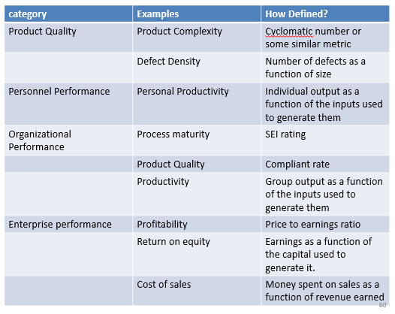
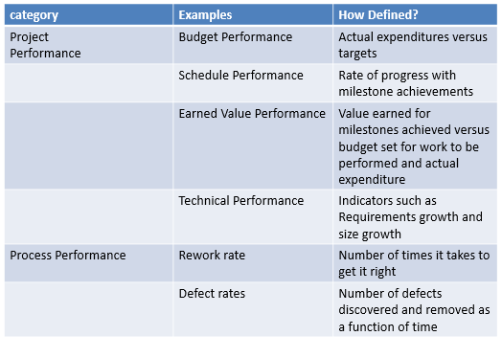

Audit
WHAT?
- independent review and examination of records and activities

WHY?
- to assess the adequacy of system controls
- ensure compliance with established policies and procedures

Applicable to:
- finances
- quality
- projects

WHO?
Internal auditor
- company employees who assess and evaluate its system of internal controls
External auditor
- an individual who assesses and evaluates an organization’s systems of internal control

WHY?
- reduce uncertainty
- determine if the project is on-track or not

Project audit
- in contrast to a financial audit, a project audit is an appraisal of the technical status of a project, or a specified part of a project, and will most usually be performed during a project rather than at its end.

WHO?
- performed by an independent auditing body external to the project team

WHEN?
- project appears to be in difficulty
- already planned on the outset of the project

WHY?
- to assess the progress of the project
- to reveal future prospects so that the recommendations of the report can influence the future conduct of the project

HOW?
- focus on a particular topic (process or procedure)
- Identify criteria against which the audit is made
- Brief the audit team, and give them access to all necessary documentation

Phase 1: initiation and planning
Phase 2: establish project baseline
Phase 3: investigation
Phase 4: analysis
Phase 5: report and present conclusions
Phase 6: termination

HUMAN RESOURCE MANAGEMENT

- is making use of people involved in a project

Consists of 4 processes:
- human resources planning
- acquiring the project team
- developing the project team
- managing the project team

Important project management areas to note are:
- motivation theories
- influence and power
- effectiveness

INTRINSIC AND EXTRINSIC MOTIVATION
Intrinsic motivation - causes people to participate in an activity for their own enjoyment
Extrinsic motivation - causes people to do something for a reward or to avoid a penalty

INTRINSIC vs EXTRINSIC
- People are usually attracted to a job for extrinsic reasons (good pay, good benefits, good working conditions)
- People usually stay with a job for intrinsic reasons (they like the people they work with, they find the job challenging, people praise them for the work they do)
- Paying people more money (extrinsic motivation) does not make them work harder. But it might keep them from leaving and it might attract new employees)
- Intrinsic motivation is what builds loyalty and dedication in your employees

MASLOW’S HIERARCHY OF NEEDS
- Physiological
- Safety
- Social
- Esteem
- Self-actualisation

HERZBERG’S MOTIVATIONAL & HYGIENE FACTORS
Motivational
- achievement
- recognition
- growth

Hygiene
- larger salaries
- more supervision
- health benefits

McGregor theory X and Y
Theory X: assumes workers dislike and avoid work, so managers must use coercion, threats and various control schemes to get workers to meet objectives
Theory Y: assumes individuals consider work as natural as play or rest and enjoy the satisfaction or esteem and self-actualization needs

Types of power
- coercive
- legitimate
- expert
- reward
- referent

Thamhain and Wilemon’s ways to have influence on projects
- authority
- assignment
- budget
- promotion
- money
- friendship

===============
Projects succeed when managers influence using:
Expertise
Work challenge

Projects fail when managers rely on:
Authority
Money
Penalty
===============

Outputs of Human Resource Planning include:
- Project organization charts
- Staffing management plan
- Responsibility assignment matrices
- Resource histograms

Responsibility Assignment Matrices
- is a matrix that maps the work of the project as described in the work breakdown structure to the people responsible for performing the work.

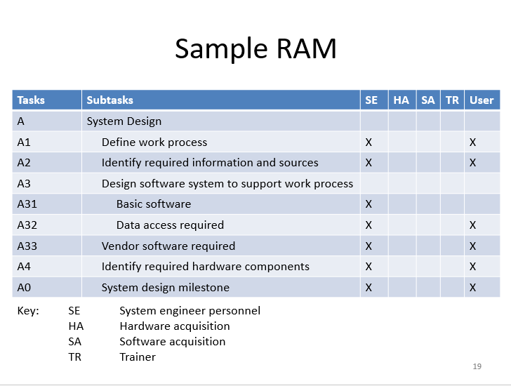

Staffing Management Plans
- describes when and how people will be added to and taken off the project team.

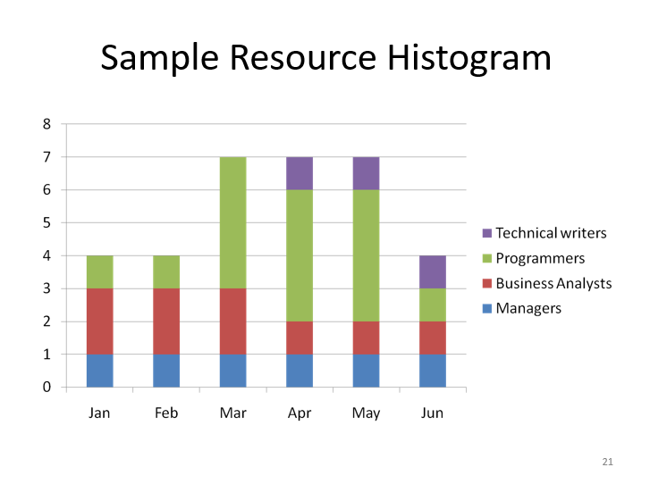

Procurement

Key factors in evaluating Vendors for MIS
- reflect financial stability
- possess an intimate knowledge of the product
- have a good corporate reputation for reliability

Project Procurement Management
- processes related to the purchase of products, services, or results necessary to perform the work.

PLAN PURCHASES AND ACQUISITION
- provides a pattern which can be used to determine which needs are better met by using an outside organization versus the project team.

INPUTS
Enterprise Environmental Factors – Enterprise environmental factors concerning mark conditions. What products, services, and results are available in the marketplace? Where can you obtain them?
Make-or-buy Decisions - Make-or-buy analysis involves comparing the relative benefits of in-house versus out-sourcing production of a given product, service, or result.

CONTRACT TYPES
There are 3 types of contracts:
Fixed-price contract – which involves a total price for a well-defined product. Fixed-price contracts may include incentives for early delivery.
Example: buying shrink wrapped software

Cost-reimbursable contract –involves payment to the vendor for actual cost plus a fee for profit. Actual costs comprise direct and indirect cost of providing the service.
There are three common types of cost-reimbursable contracts.
- Cost-Plus-Fee (CPF) or Cost-Plus-Percentage of Cost (CPPC): the seller is reimbursed for the allowable costs and receives a percentage of the costs as a fee.
- Cost-Plus-Fixed-Fee (CPFF): the vendor is reimbursed for allowable costs and receives a fixed fee. The fee normally doesn’t change unless scope changes allocate a new fee.
- Cost-Plus-Incentive-Fee (CPIF): Cost-Plus-Incentive reimburses the seller for allowable costs and allocates a predetermined fee, as an incentive for achieving certain performance objectives.

Time and Material contracts – which is a hybrid combination of cost-reimbursable and fixed price contracts. A common indicator is their open-ended nature. The full value of the agreement and the exact quantity of items to be delivered are not defined at the time of contract award.

Outputs
Requested changes – requested changes to the plan should be placed into the integrated change control process.

